DOCUMENTATION FOR RIFA’S PORTFOLIO WEBSITE
1. Brief Explanation of HTML Concepts Learned
In this project, I applied the following HTML concepts:
Basic HTML Structure
Used <!DOCTYPE html>, <html>, <head>, and <body> to define the structure of the webpage.
Semantic Tags
- <header>: Contains the title and navigation links.
- <nav>: Used for internal page navigation (About, Skills, Contact).
- <main>: Holds the main content of the portfolio.
- <aside>: Displays the profile image.
- <article>: Contains the main sections (About, Skills, Contact).
- <footer>: Displays copyright information.
Text Formatting
- Headings: <h1>, <h3>, <h4>
- Paragraphs: <p>
- Line breaks: <br>
- Horizontal lines: <hr>
- Links and Navigation
- Anchor tags <a> are used for:
- Internal navigation using IDs (#about, #skills, #contact)
- External links to GitHub and LinkedIn profiles.
Images
<img> tag is used to display a profile picture with styling such as border and rounded corners.
Lists
<ul> and <li> are used to list skills in an organized manner.
Forms
<form> is used to collect user data.
Inputs:
- Text input (type="text")
- Email input (type="email")
- Phone input (type="tel")
- Textarea for queries
The form is connected to Formspree to receive submissions.
Grouping Content
<fieldset> and <legend> are used to visually separate and label sections like About, Skills, and Contact.
2. Portfolio Structure
The portfolio is structured as follows:
Portfolio Page
│
├── Header
│ ├── Title (Welcome to Rifa’s Portfolio)
│ ├── Navigation Menu (About | Skills | Contact)
│
├── Main
│ ├── Aside
│ │ └── Profile Image
│ │
│ └── Article
│ ├── About Section
│ │ ├── Introduction
│ │ ├── GitHub Link
│ │ └── LinkedIn Link
│ │
│ ├── Skills Section
│ │ └── List of Technical Skills
│ │
│ └── Contact Section
│ ├── Phone Number
│ └── Contact Form
│
└── Footer
└── Copyright Information
Quality Standards Checklist
1. Project Overview
This portfolio website is designed to:
- Introduce myself and my technical background.
- Display my skills and areas of expertise.
- Provide easy access to my GitHub and LinkedIn profiles.
- Allow visitors to contact me using a form.
- It serves as a personal branding platform and a professional showcase.
2. Setup Instructions
- Create a folder named portfolio.
- Save the file as index.html.
- Place your image rifa.jpg inside the same folder.
- Open index.html using any browser.
- Ensure internet connectivity for:
- GitHub & LinkedIn links.
- Formspree form submission.
No extra software is required.
3. Code Structure
The code is divided into clear sections:
Header → Navigation
Main → Profile Image + Content Sections
Footer → Copyright
IDs (about, skills, contact) are used for clean navigation.
Form elements are organized inside a table for neat layout.
Reusable HTML tags are used to maintain clarity and simplicity.
4. Visual Documentation
Home page showing:
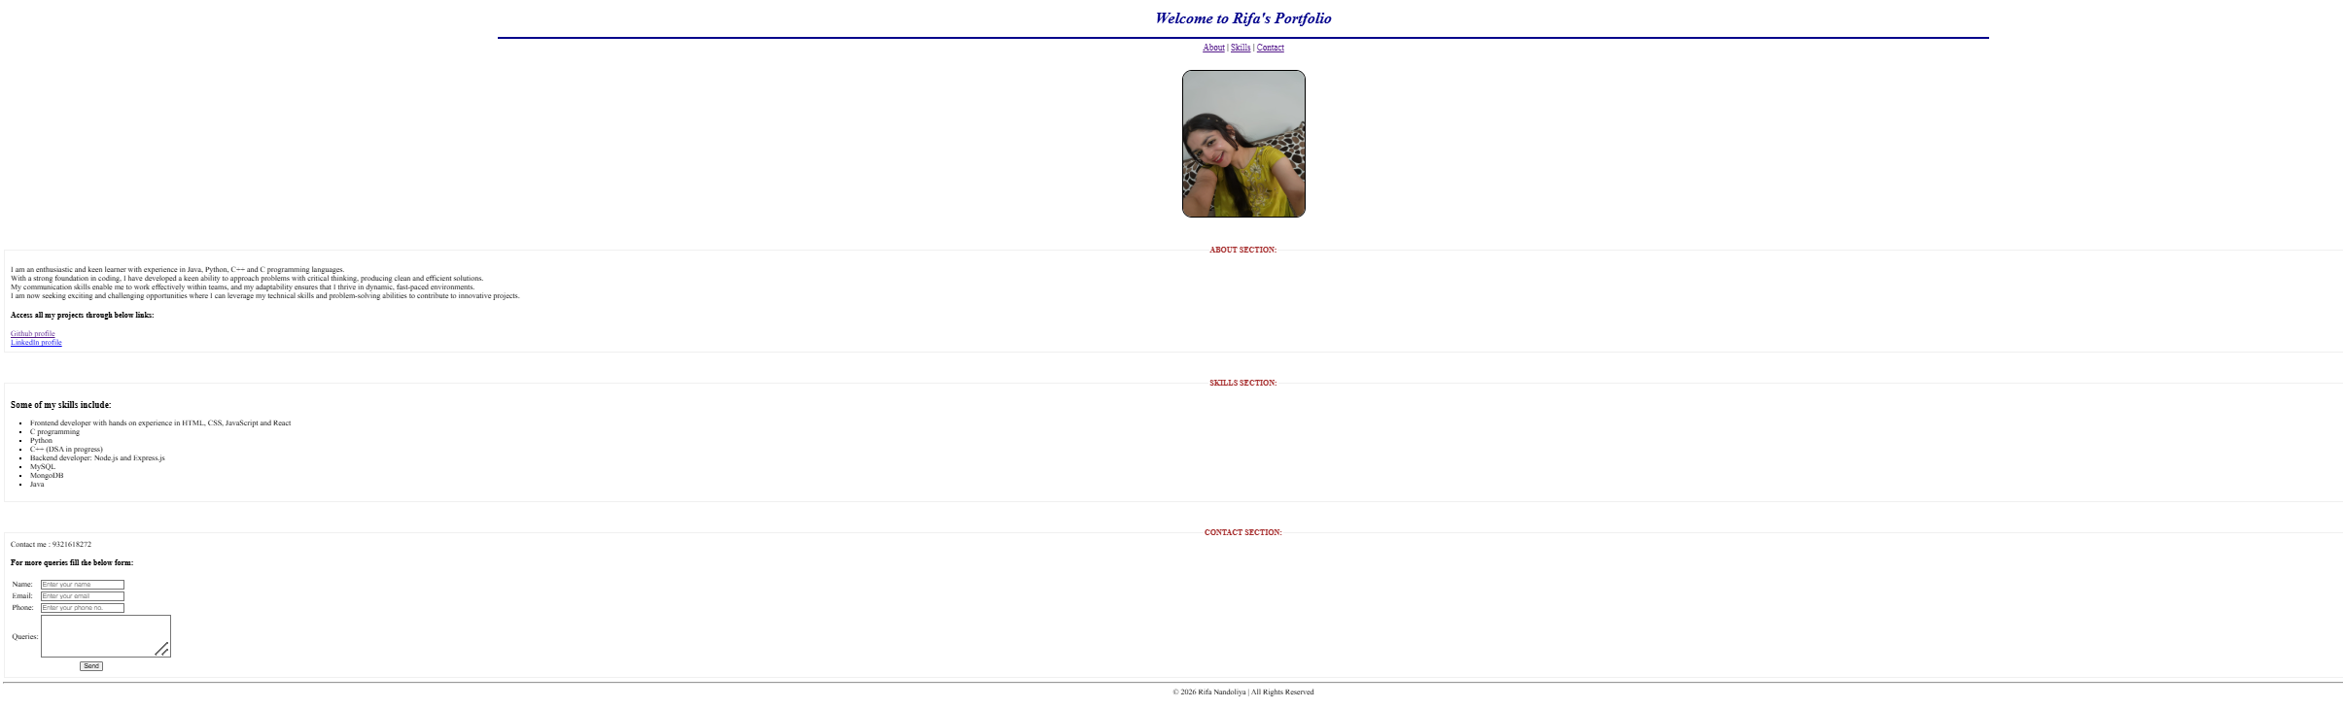
Header and navigation:

About section showing:
Skills section showing:
Contact section showing:
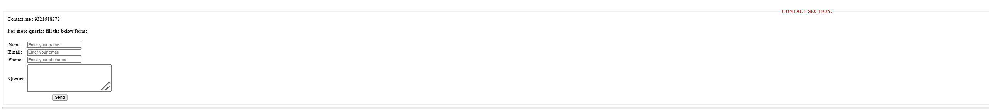
Footer:
These screenshots demonstrate layout, styling, and functionality.
5. Technical Details
Form Handling
Form is connected to Formspree using:
action="https://formspree.io/f/xnjjnakv"
method="post"
Data is sent securely to Formspree servers.
Input Validation
Email uses type="email" for automatic format checking.
Phone uses type="tel".
Navigation Logic
Clicking on navigation links scrolls to respective sections using IDs.
Styling
Inline CSS and HTML attributes used for:
Image border and radius
Colors
Text alignment
6. Testing Evidence
Test Cases:
a. Navigation links -> About/Skills/Contact
Status: Pass
b. GitHub link -> opens GitHub profile in a new tab
Status: Pass
c. LinkedIn link -> opens LinkedIn profile
Status: Pass
d. Contact Form -> data sent to Formspree successfully
Status: Pass

